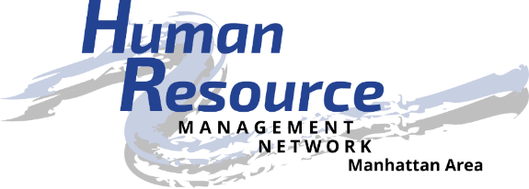
Be the catalyst to empower the advancement of human resources.

Job Description

Position: Certification Liaison
Position Summary: Manage the chapter’s SHRM certification program. Increase the number of chapter members who are certified SHRM-CP or SHRM-SCP by the SHRM Certification Commission or PHR or SPHR by HRCI. Encourage members to become certified and recertified.
Responsible To:
- The members of the chapter
- The chapter president and board of directors
- The state council certification director
Essential Duties and Responsibilities:
- Coordinate with the lead instructor and/or lead, plan, and arrange for speakers and materials at the SHRM certification study group meetings.
- Promote benefits of SHRM certification.
- Inform membership of the chapter’s SHRM certification study group at membership meetings and though available chapter communication media.
- Provide information to members about alternative study methods in lieu of study group.
- Recognize members who became SHRM and/or HRCI certified.
- Inform membership director of SHRM and HRCI certified members.
- Inform members of recertification Professional Development Credits (PDCs), including online tracking program.
- Provide information about any changes in recertification requirements.
- Secure and maintain the SHRM Certification Preferred Provider and HRCI status for applicable chapter programs.
- Collaborate with program director to secure SHRM and HRCI PDC’s for monthly chapter programs.
- Maintain communication with the state council certification director and SHRM staff as needed.
- Participate in SHRM Certification Core Leadership Area teleconferences/webcasts.
- Participate in the development and implementation of short-term and long-term strategic planning for the chapter.
- Represent the chapter in the human resource community.
- Attend all monthly membership and board of director’s meetings.
Other Duties and Responsibilities:
- As an active Board member, submit agenda items for board and chapter meetings, ask critical questions, and assist with Board decisions that affect Chapter membership.
- Must be in “good standing” within the Chapter.
- Know or build knowledge about the local organization and SHRM. Follow SHRM Code of Ethics
- Stay informed of human resource trends and timely issues affecting the profession and organization.
- Assist with social media applications.
Requirements:
- Chapter certification director must be certified as a SHRM-CP or SHRM-SCP by the end of 2015.
- Must present a professional appearance and friendly manner
- Must be dependable and punctual
- Willingness to participate and engage in chapter and community activities as a volunteer
- Be courteous and personable when dealing with the public
- Be self-directed, willing to take initiative, and detail-oriented
- Respect and maintain confidentiality of HRMN volunteers, partners, and donors
- Computer skills are desired, but not necessary
Training & Resources:
- Attend Volunteer Leadership Academy
- HRMN By-laws
- HRMN website http://hrmn.shrm.org
- Volunteer Leadership Resource Center website http://community.shrm.org/vlrc/home
- SHRM website http://shrm.org
Time Commitment:
- Once per month for board meeting (approximately 1.5 hours, typically 8:00 – 9:30 am)
- Once per month for membership meeting (approximately 1.5 hours)
- Once per week when certification course is being held (potentially 3 hours)
Benefits:
- Volunteer opportunities
- Community involvement
- Apply, develop and improve leadership skills
- Build and improve your HR competencies
- Expand your professional network – locally, regionally and nationally
- Share your knowledge and learn from others
- Build relationships of trust
- Be a recognized catalyst for the HR profession
- Be recognized by external stakeholders for your HR expertise

Human Resource Management Network of Manhattan, KS, an affiliate of the Society for Human Resource Management, is located in the heart of the Flint Hills of eastern Kansas. Membership is composed of management and administrative level persons responsible for human resource related activities in the organizations. Our local chapter includes members from several local communities and surrounding counties. We are a local resource for networking, information, professional development, and continued support of excellence in Human Resources. For more information, visit www.hrmn.shrm.org.

