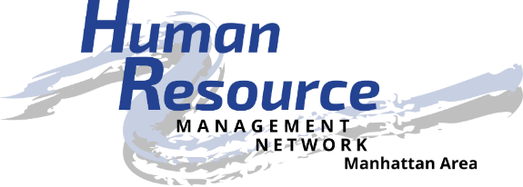
Be the catalyst to empower the advancement of human resources.

Job Description

Position: Secretary
Position Summary: Record and maintain minutes of chapter board and general membership meetings and general correspondence. Monitor chapter email and post office box and disseminate mail to appropriate board members. Maintain official records of the chapter. Prepare correspondence on behalf of the chapter as necessary.
Responsible To:
- Members of the chapter
- Chapter president and board of directors
Essential Duties and Responsibilities:
- Prepare the minutes of all board and chapter membership meetings. Submit final minutes for review and approval by the board of directors and the general membership.
- Maintain and electronically file permanent Chapter records to include, but not limited to:
  - Signed chapter bylaws and dated copies of amendments to those bylaws.
  - Approved minutes of all board and general membership meetings.
  - Officer and director position descriptions.
- Monitor HR Management Network email account and post office box. Disseminate electronic and physical mail to appropriate individuals for action.
- Monitor and maintain HR Management Network Google Drive files.
- Participate in the development and implementation of short-term and long-term strategic planning for the chapter.
- Represent the chapter in the human resource community.
- Attend all monthly membership and board of director’s meetings.
Other Duties and Responsibilities:
- Provide contacts and resources to help grow and develop the organization and its members.
- As an active Board member, submit agenda items for board and chapter meetings, ask critical questions, and assist with Board decisions that affect Chapter membership.
- Must be in “good standing” within the Chapter.
- Know or build knowledge about the Chapter and SHRM.
- Follow SHRM Code of Ethics.
- Stay informed of human resource trends and timely issues affecting the profession and organization.
- Assist with social media applications.
- Maintain confidentiality of chapter board issues and membership data.
- Maintain adequate records for use by successors and other board members.
- SHRM membership is strongly encouraged.
Requirements:
- Present a professional appearance and friendly manner
- Be dependable and punctual
- Willingness to participate and engage in chapter and community activities as a volunteer
- Be courteous and personable when dealing with the public
- Be self-directed, willing to take initiative, and detail-oriented
- Respect and maintain confidentiality of HRMN volunteers, partners, and donors
- Computer skills are desired, but not necessary
Training & Resources:
- Attend Volunteer Leadership Academy
- HRMN By-laws
- HRMN website http://hrmn.shrm.org
- Volunteer Leadership Resource Center website http://community.shrm.org/vlrc/home
- SHRM website http://shrm.org
Time Commitment:
- Once per month for board meeting (approximately 1.5 hours, typically 8:00 – 9:30 am)
- Once per month for membership meeting (approximately 1.5 hours)
- Typing and distribution of meeting minutes (approximately 1.5 hours per month)
- Monitor electronic and paper mail and distribute (approximately 1.5 hours per month)
Benefits:
- Volunteer opportunities
- Community involvement
- Apply, develop and improve leadership skills
- Build and improve your HR competencies
- Expand your professional network – locally, regionally and nationally
- Share your knowledge and learn from others
- Build relationships of trust
- Be a recognized catalyst for the HR profession
- Be recognized by external stakeholders for your HR expertise

Human Resource Management Network of Manhattan, KS, an affiliate of the Society for Human Resource Management, is located in the heart of the Flint Hills of eastern Kansas. Membership is composed of management and administrative level persons responsible for human resource related activities in the organizations. Our local chapter includes members from several local communities and surrounding counties. We are a local resource for networking, information, professional development, and continued support of excellence in Human Resources. For more information, visit www.hrmn.shrm.org.

